# 

# Department of Computer Engineering

Internship Report

*Submitted in partial fulfilment of the requirements for the degree of*

# BACHELOR OF ENGINEERING

In

# COMUTER ENGINEERING

*Submitted By*

# Aniket Bidgar

Roll No.: 21CO026

Under the Guidance of

# Mrs. S. R. Nalamwar

Academic Year: 2023-24(Term-II)

# Savitribai Phule Pune University



DEPARTMENT OF COMPUTER ENGINEERING

# CERTIFICATE

This is to certify that Aniket Bidgar from Third Year Computer Engineering has successfully completed his work titled "Internship Report" at AISSMS College of Engineering, Pune in the partial fulfilment of the Bachelor's Degree in Engineering.

### Mrs. S. R. Nalamwar

Faculty Guide Computer Engineering

### Dr. S. V. Athawale

HOD Computer Engineering

Prof. S. G. Dhengre   
 Internship Coordinator Computer Engineering

### Dr. D. S. Bormane

Principal AISSMS COE, Pune

# TABLE OF CONTENT

|  |  |  |
| --- | --- | --- |
| Sr. No | Chapter Name | Page No. |
| 1 | Acknowledgement | 4 |
| 2 | Abstract | 5 |
| 3 | Organization Details | 6 |
| 4 | Internship Allotment Letter | 7 |
| 5 | Internship Completion Letter | 8 |
| 5 | Responsibilities | 9 |
| 7 | Skills Earned | 10 |
| 9 | Project Outcomes | 18 |
| 10 | Attendance | 22 |
| 11 | Experience | 23 |
| 12 | Conclusion | 24 |
| 13 | References | 25 |
| 14 | Formats | 26 |

# ACKNOWLEDGEMENT

It gives me a great pleasure to acknowledge the contribution of all those who have directly or indirectly contributed to the completion of this seminar.

First of all, I would like to thank my Institute, All India Shri Shivaji Memorial Society's College of Engineering, Pune for arranging an internship program. I am also grateful to Elite Software for recruiting me as an intern.

I take this opportunity to express my profound gratitude and deep regards to my supervisor Mr. Swami Panjala for his exemplary guidance, monitoring and constant encouragement throughout the course of this internship. The blessing, help and guidance given by him time to time shall cany me a long way in the journey of life on which I am about to embark.

### I would like to express my heartfelt gratitude to my faculty mentor Mrs. S. R. Nalamwar , our internship Co-Ordinator Prof. S. G. Dhengre, HOD Dr. S. V. Athawale, Principal Dr. D. S. Bormane All India Shri Shivaji Memorial Society's College of Engineering, Pune for their kind support during my internship program.

### Academic Year:2023-24

Name: Aniket Bidgar Roll No: 21CO026

Abstract

Python-Django is a high-level web framework built in Python. Django provides a convenient way to build web applications quickly, with its clean and pragmatic design philosophy. Django follows the Model-View-Template (MVT) pattern, which is similar to the Model-View-Controller (MVC) pattern but with some differences, making it easier to develop web applications. A Python-Django internship can be a great way to learn web development with Python, and gain hands-on experience building real-world web applications. During the internship, you are likely to learn how to set up the Django framework, including creating virtual environments, installing dependencies, and configuring database settings. You will also learn how to build web applications with Django, including creating models, views, and templates, working with URL routing, handling forms and user inputs, and integrating third-party libraries and APIs to enhance the functionality of the application. In addition, you may also learn how to deploy a Django application to a web server, including configuring web servers, working with DNS settings, and configuring SSL certificates for secure HTTPS connections. Throughout the internship, you will get a chance to work on real-world projects, collaborate with other developers, and receive feedback and guidance from experienced professionals. By the end of the internship, you should have a solid understanding of web development with Python-Django, and be able to build your own web applications from scratch.

Web development using Python-Django framework is a popular choice for building complex and dynamic web applications. Django is a high-level web framework that is designed to facilitate rapid development and clean, pragmatic design. Python, being a versatile and robust programming language, provides a wide range of libraries and frameworks that simplify web development. Django provides a set of powerful tools and libraries that enable developers to build secure, scalable, and maintainable web applications. These tools include an Object-Relational Mapping (ORM) system for database management, a templating engine for rendering HTML pages, and a built-in web server for testing and debugging.

# Organization Details

# Elite Softwares | LinkedIn

|  |  |
| --- | --- |
| Company background-Organization | Elite Softwares |
| Activities/Scope | Only for School and College ERP (Enterprise Resource Planning) Software and Technical Workshops for Entrepreneurship Development |
| Objective of Study | * Learning web development * Improving Python programming skills * Gaining experience with database management * Understanding software development life cycle * Building a portfolio |
| Supervisor | Mr. Swami Panjala |
| Details(Name, Designation, Company Name, Email Id, Contact number) | * Founder and CEO * [swami@elitesoftwares.co.in](mailto:swami@elitesoftwares.co.in) * 9096622683 |

Internship Allotment Letter

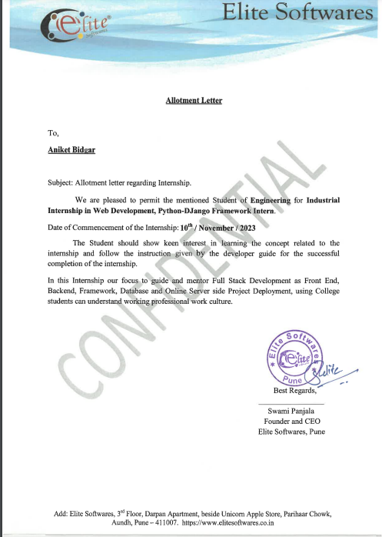

Internship Completion Letter

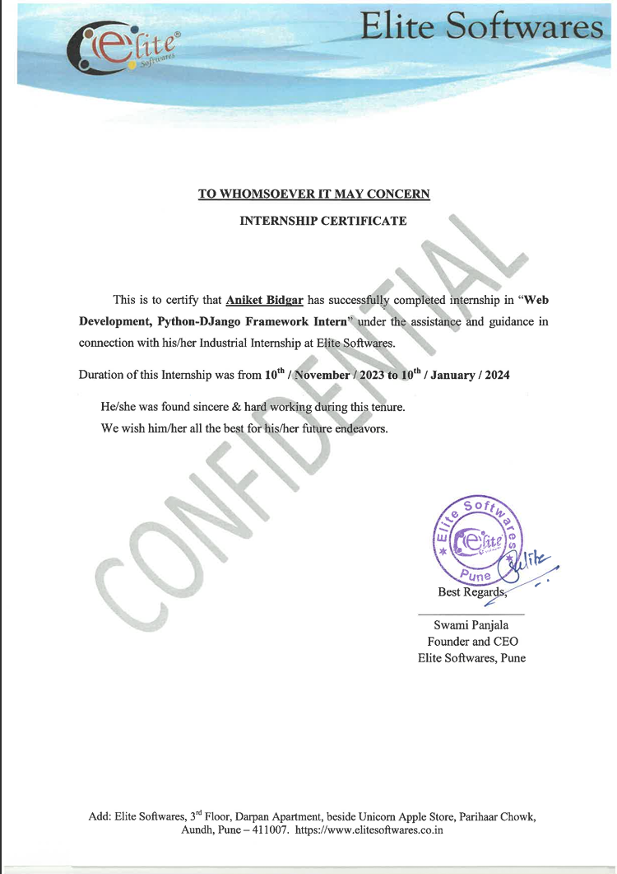

# 

# Responsibilities

The responsibilities of an intern, in a web developer, may vary depending on the specific project and the organization offering the internship. However, my everyday

responsibilities include the following:

* Website Development: Actively participate in designing, developing, and maintaining websites and web applications.
* Responsive Design: Learn and apply responsive design principles to create websites that are visually appealing and accessible on desktops, tablets, and smartphones.
* Mobile-First Approach: With the increasing use of smartphones and tablets, websites are now designed to priorities mobile user experience.
* Testing and Optimization: Web developers must ensure that their code is efficient and reliable.
* Learning and Skill Enhancement: Throughout the internship, you will be encouraged to expand your knowledge and stay up to date with the latest trends and technologies in web development.

# 

# Skills Earned

* Practical Experience: Internships provide hands-on experience, allowing you to apply the theoretical knowledge gained in classrooms to real-world projects. This practical experience is invaluable for understanding how web development works in practice.
* Skill Enhancement: You'll likely enhance your technical skills in areas such as HTML, CSS, JavaScript, and possibly various frameworks and libraries like Bootstrap and Django. Additionally, you may gain proficiency in using development tools and software like Git, IDEs, and project management tools.
* Portfolio Building: As you work on real projects during your internship, you'll have the opportunity to build a portfolio showcasing your work. A strong portfolio is essential for landing future job opportunities in web development.
* Networking: Internships often allow you to network with professionals in the industry. Building connections with colleagues, mentors, and supervisors can open doors to future job opportunities and provide valuable insights into the industry.
* Resume Enhancement: Having an internship experience on resume demonstrates to potential employers that you have practical experience in the field. It can make you a more attractive candidate for entry-level web development positions or other roles in the tech industry.
* Feedback and Mentorship: Internships typically involve working closely with experienced professionals who can provide feedback on your work and offer mentorship. This guidance can help you identify areas for improvement and grow as a developer.
* Exploration of Career Paths: Internships allow to explore different aspects of web development and determine which areas you enjoy the most. Whether it's front-end development, back-end development, full-stack development, or specialization in a particular technology, internships can help you clarify your career goals.

#### HTML:

HTML, or Hypertext Markup Language, is the standard markup language used to create and design web pages. It provides the structure and content of a webpage by using a system of tags and attributes. These tags are interpreted by web browsers to render the content in a visually understandable format for users.

HTML documents are comprised of elements, which are defined by tags enclosed in angle brackets <>. Each HTML tag serves a specific purpose and defines different parts of the content, such as headings, paragraphs, images, links, forms, and more.

HTML Documents:

All HTML documents must start with a document type declaration:

<!DOCTYPE html>. The HTML document itself begins with </html> and ends with </html>.

The visible part of the HTML document is between <body> and </body>.

HTML Heading:

HTML headings are defined with the <h1> to <h6> tags. <h1> defines the most important heading. <h6> defines the least important heading.

<h1>This is heading 1</h1>

<h2>This is heading 2</h2>

<h3>This is heading 3</h3>

HTML Paragraphs:

HTML paragraphs are defined with the <p> tag.

<p>This is paragraph </p>

<p>This is another paragraph </p>

#### HTML Images:

HTML images are defined with the <img> tag`. The source file (src), alternative text (alt), width, and height are provided as attributes.

HTML Table:   
 An HTML table is a structured way to display data in rows and columns on a web page. Tables are defined using the <table> element, with additional elements to define rows (<tr>), columns (<th> for table headers and <td> for table data), and another table-related element  
  
CSS:

Cascading Style Sheets (CSS) is a style sheet language used for describing the presentation of a document written in a markup language such as HTML. CSS is a cornerstone technology of the World Wide Web, alongside HTML and JavaScript.

CSS is designed to enable the separation of presentation and content, including layout, colors, and fonts. This separation can improve content accessibility; provide more flexibility and control in the specification of presentation characteristics; enable multiple web pages to share formatting by specifying the relevant CSS in a separate .css file, which reduces complexity and repetition in the structural content; and enable the .css file to be cached to improve the page load speed between the pages that share the file and its formatting.

Separation of formatting and content also makes it feasible to present the same markup page in different styles for different rendering methods, such as on-screen, in print, by voice (via speech-based browser or screen reader), and on Braille-based tactile devices. CSS also has rules for alternate formatting if the content is accessed on a mobile device.

The name cascading comes from the specified priority scheme to determine which style rule applies if more than one rule matches a particular element. This cascading priority scheme is predictable.

The CSS specifications are maintained by the World Wide Web Consortium (W3C). Internet media type (MIME type) text/css is registered for use with CSS by RFC 2318 (March 1998). The W3C operates a free CSS validation service for CSS documents.

In addition to HTML, other markup languages support the use of CSS including XHTML, plain XML, SVG, and XUL.

CSS (Cascading Style Sheets) is connected to HTML (Hypertext Markup Language) through the process of styling. HTML provides the structure and content of a web page, while CSS defines the presentation, layout, and appearance of that content.

CSS is linked to HTML documents using one of the following methods:

**Inline Styles**: Styles can be applied directly to individual HTML elements using the style attribute.

Internal Styles: Styles can be included within the <style> element in the <head> section of an HTML document.

External Stylesheets: Styles can be defined in separate CSS files and linked to HTML documents using the <link> element.

JavaScript:

JavaScript (JS) is a lightweight, interpreted, or just-in-time compiled programming language with first-class functions. While it is most well-known as the scripting language for Web pages, many non-browser environments also use it, such as Node.js, Apache CouchDB and Adobe Acrobat. JavaScript is

a prototype-based, multi-paradigm, single-threaded, dynamic language, supporting object-oriented, imperative, and declarative (e.g. functional programming) styles.

JAVASCRIPT is a MUST for students and working professionals to become a great Software Engineer specially when they are working in Web Development Domain. I will list down some of the key advantages of learning JAVASCRIPT:

* Simple − JavaScript is simple to comprehend and pick up.
* Speed − JavaScript is a "interpreted" language, it cuts down on the time needed for compilation in other programming languages like Java.
* Interoperability − Because JavaScript seamlessly integrates with other programming languages, many developers favor using it to create a variety of applications.
* Server Load − Data validation can be done within the browser itself rather than being forwarded to the server because JavaScript is client- side.

Applications of JAVASCRIPT

* Web Development
* Web Applications
* Presentations
* Server Applications
* Web Servers
* Games
* Art

JAVASCRIPT Operators

Operators are used to perform operations on variables and values. JAVASCRIPT divides the operators in the following groups:

* Arithmetic operators
* Assignment operators
* Comparison operators
* Increment/Decrement operators
* Logical operators
* String operators
* Conditional Assignment Operator
* Array operators

Bootstrap:

Bootstrap is a popular front-end framework for developing responsive and mobile-first websites and web applications. Developed by Twitter, Bootstrap provides a collection of pre-designed HTML, CSS, and JavaScript components, as well as customizable themes, that can be used to quickly build modern and visually appealing user interfaces.

Key features of Bootstrap include:

* Responsive Design: Bootstrap's grid system and responsive CSS classes make it easy to create layouts that adapt and reflow to different screen sizes and devices, such as desktops, tablets, and smartphones.
* CSS Components: Bootstrap includes a wide range of CSS components, such as buttons, forms, navigation bars, dropdowns, alerts, modals, and more, that can be easily integrated into web projects. These components are styled and designed to provide a consistent and professional appearance across different browsers and devices.
* JavaScript Plugins: Bootstrap offers JavaScript plugins that enhance the functionality of web pages, including features like carousels, tooltips, popovers, modals, Scrollspy, and more. These plugins are customizable and can be easily incorporated into Bootstrap projects.
* Customizable Themes: Bootstrap comes with built-in themes and customization options, allowing developers to easily modify the look and feel of their websites by adjusting variables, colors, fonts, and other style settings.
* Documentation and Community: Bootstrap provides comprehensive documentation, examples, and guides to help developers get started with the framework. Additionally, Bootstrap has a large and active community of developers who contribute to its ongoing development, provide support, and share resources and tips.
* Browser Compatibility: Bootstrap is designed to be compatible with modern web browsers, ensuring consistent rendering and functionality across different platforms and devices.

Bootstrap 5 (released 2021) is the newest version of Bootstrap (released 2013); with new components, faster stylesheet and more responsiveness.

Bootstrap 5 supports the latest, stable releases of all major browsers and platforms. However, Internet Explorer 11 and down is not supported.

The main differences between Bootstrap 5 and Bootstrap 3 & 4, is that Bootstrap 5 has switched to vanilla JavaScript instead of jQuery.

#### Django:

Django is a high-level Python web framework that encourages rapid development and clean, pragmatic design. It's designed to make building web applications easier by providing reusable components and adhering to the "don't repeat yourself" (DRY) principle.

Key features of Django include:

* Object-Relational Mapping (ORM): Django provides an abstraction layer over the database, allowing developers to interact with the database using Python objects. This makes database operations more intuitive and helps prevent common security vulnerabilities like SQL injection.
* Admin Interface: Django includes a built-in admin interface that allows developers to perform CRUD (Create, Read, Update, Delete) operations on the application's data models without having to write custom code.
* URL Routing: Django uses a URL dispatcher to route incoming web requests to the appropriate view functions, making it easy to create clean and maintainable URL structures.
* Template Engine: Django comes with a powerful template engine that allows developers to build dynamic HTML pages by combining HTML with Python-like template tags and filters.
* Authentication and Authorization: Django provides built-in support for user authentication, session management, and permissions, making it easy to add user authentication and access control to web applications.
* Security: Django includes built-in protection against common security threats like SQL injection, cross-site scripting (XSS), and cross-site request forgery (CSRF).
* Internationalization and Localization: Django includes built-in support for internationalization (i18n) and localization (l10n), making it easy to translate web applications into multiple languages.
* Testing Support: Django provides a robust testing framework that makes it easy to write and execute tests for web applications.

Overall, Django is a powerful and popular framework for building web applications in Python, known for its simplicity, scalability, and flexibility. It's used by companies and developers around the world to build a wide range of web applications, from simple blogs to complex enterprise systems.

Django follows the MVT design pattern (Model View Template).

* Model - The data you want to present, usually data from a database.
* View - A request handler that returns the relevant template and content - based on the request from the user.
* Template - A text file (like an HTML file) containing the layout of the web page, with logic on how to display the data.

Model:

The model provides data from the database. In Django, the data is delivered as an Object Relational Mapping (ORM), which is a technique designed to make it easier to work with databases. The most common way to extract data from a database is SQL. One problem with SQL is that you have to have a pretty good understanding of the database structure to be able to work with it. The models are usually located in a file called models.py.

View:

A view is a function or method that takes http requests as arguments, imports the relevant model(s), and finds out what data to send to the template, and returns the final result. The views are usually located in a file called views.py.

Template:

A template is a file where you describe how the result should be represented.

Templates are often .html files, with HTML code describing the layout of a web page, but it can also be in other file formats to present other results, but we will concentrate on .html files.

* Domain Name:

A domain name is a website’s address on the internet where people can access your website. It’s what internet users type in the URL bar of the browser to visit your website. For example, bigrock.in.

Primarily, domain names have two parts that are separated by a dot. The first is your company/brand name or any word of your choice (like “bigrock” in the above example), which can have any combination of numbers and letters. And the second part is known as domain extension or TLD, for example, .org, .in, .net, .com, and .uk (like .in in the above example). Every domain is unique and there can never be two same domain names

* Hosting:

Web hosting is basically where your website files are stored. It is like your website’s home. Let’s understand this with an illustration.

If your domain is your house’s address, then your hosting server is the house. And that is why you need both web hosting as well as a domain name to create a website.

When a user tries to access your website by entering your domain name (your web address) in the browser, the domain name points the user to the website files stored on the web server. The web hosting then makes your website files available for anyone on the internship

Project Outcomes

Home Page:

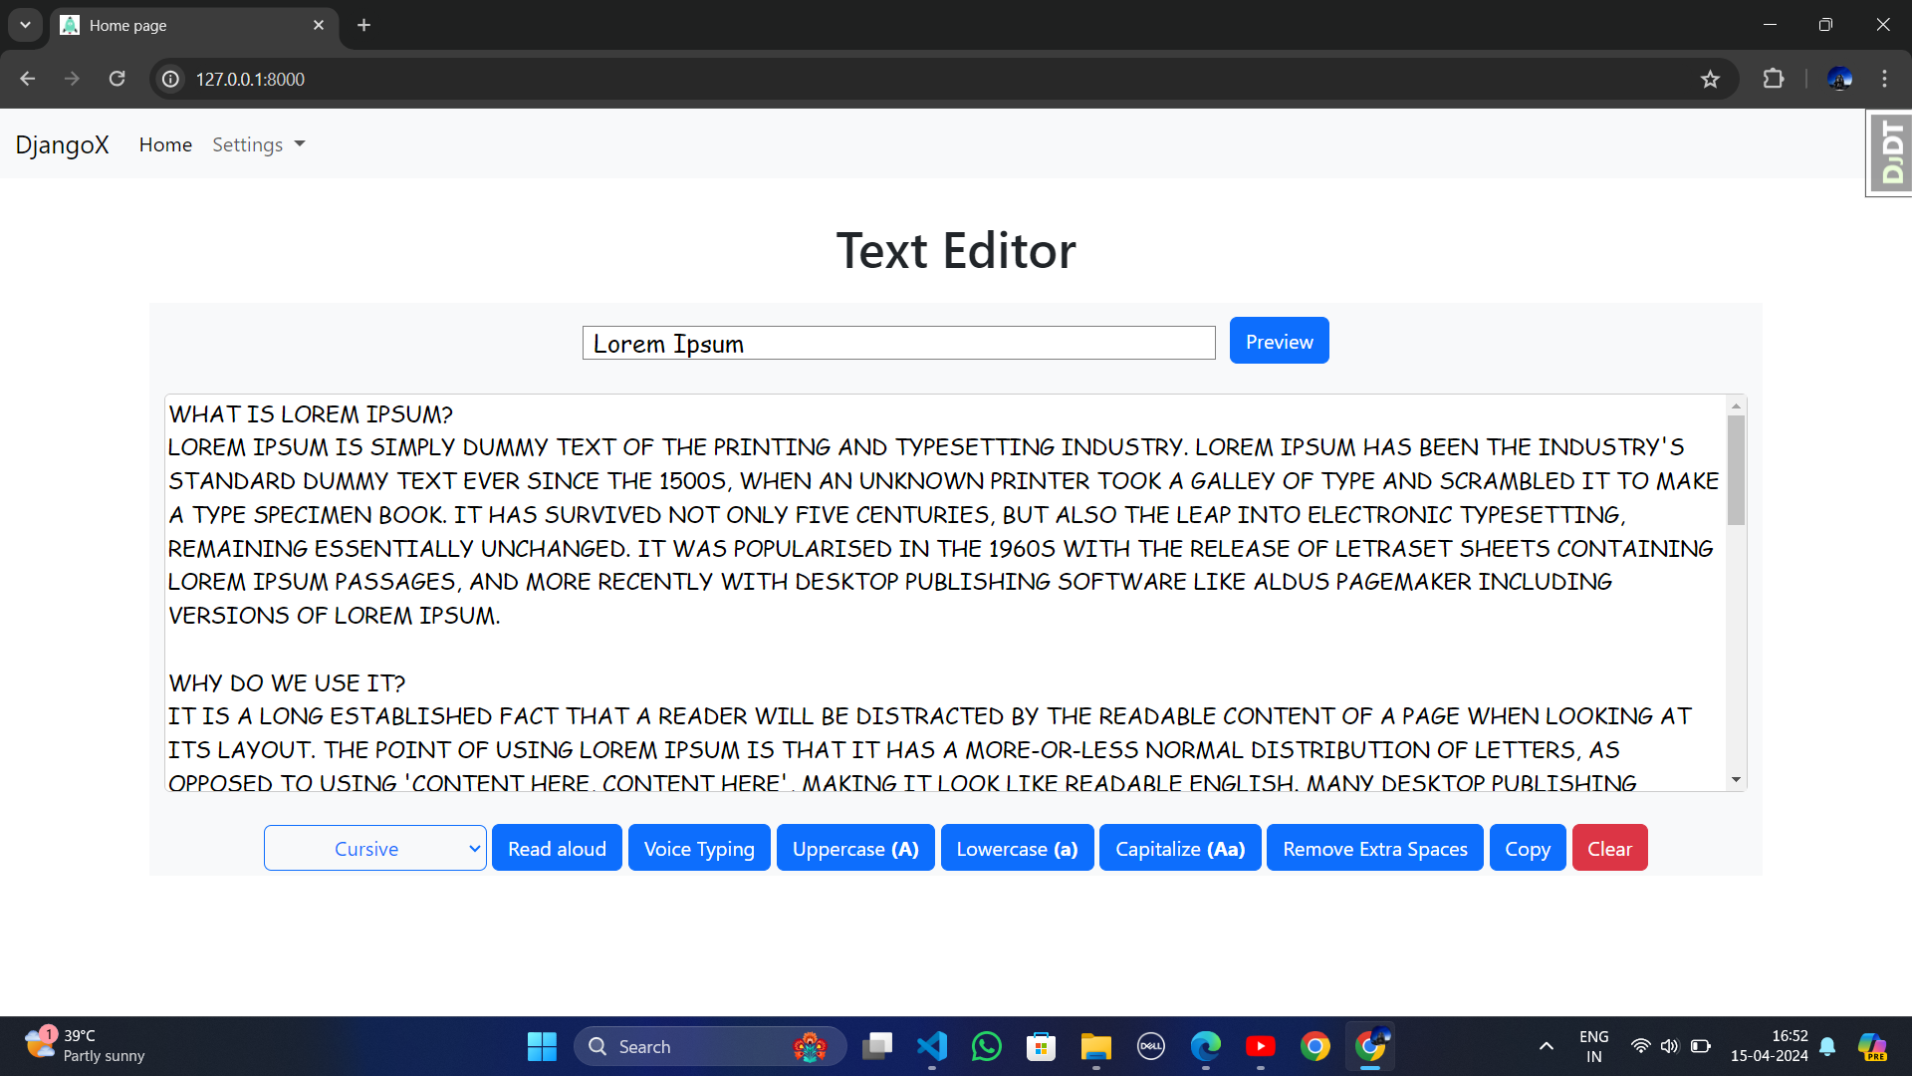

Preview Page:

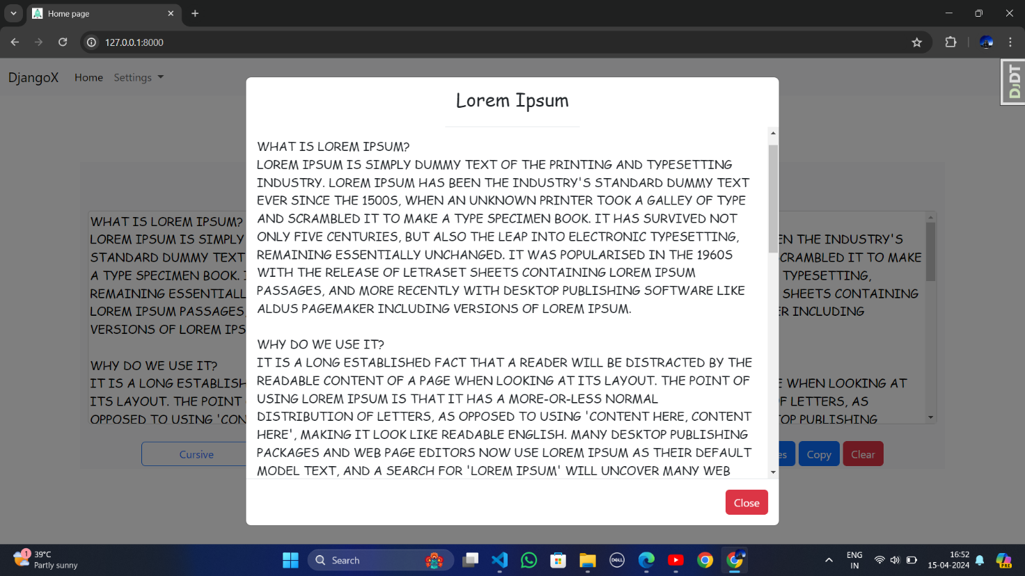

Base.html:

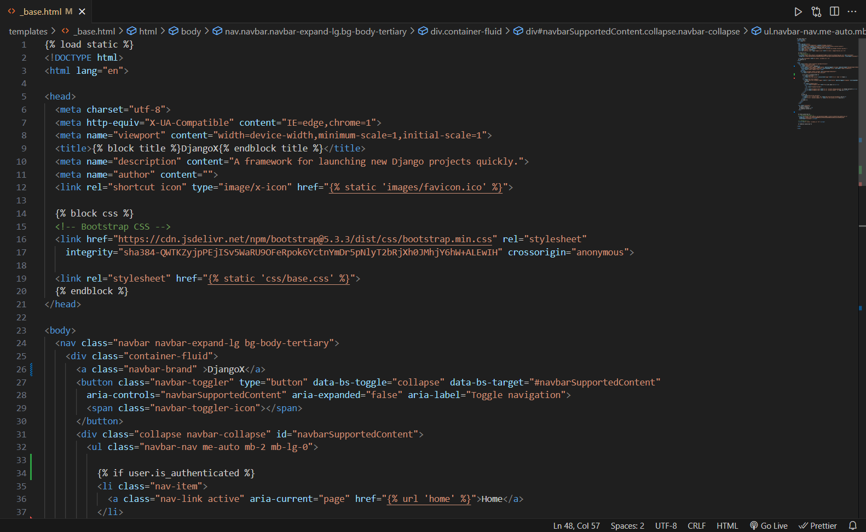

Index.html:

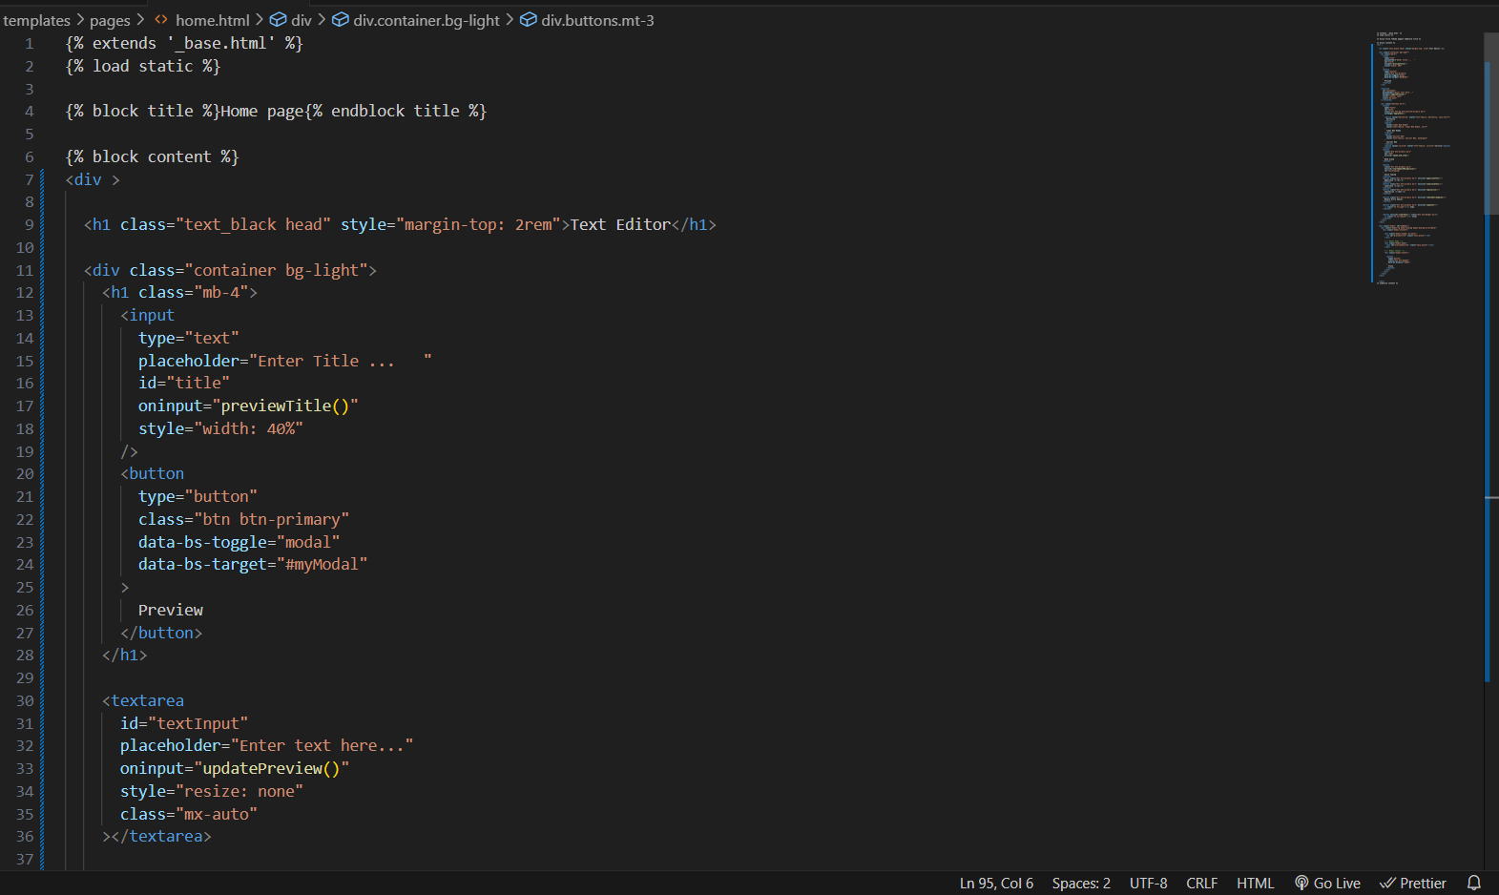

Admin Login Page:

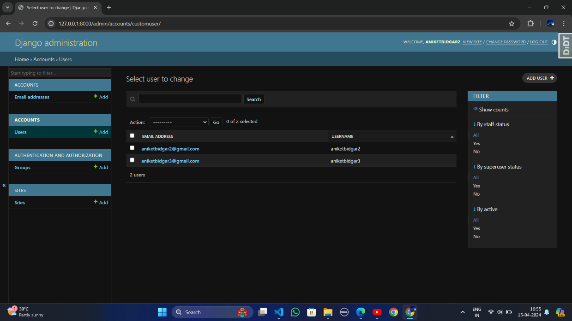

User Login Page :

# 

Signup Page:

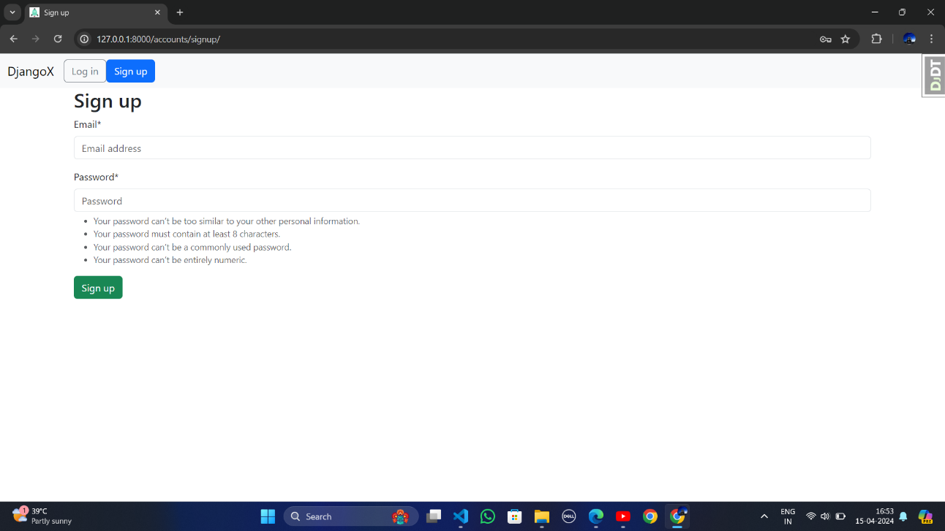

Change Password Page:

# 

# 

# Attendance

# Internship Experience

During my internship in frontend development and Django, I was immersed in a dynamic learning environment that provided hands-on experience and valuable insights into the world of web development. Working with HTML, CSS, and JavaScript, I tackled various frontend projects aimed at creating user-friendly interfaces with an emphasis on responsiveness and accessibility. Through these projects, I gained practical skills in translating design mockups into fully functional web experiences while adhering to best practices and industry standards.

Simultaneously, I delved into backend development using Django, where I explored server-side programming, database management, and RESTful API development. Utilizing Django's robust features such as ORM and templating engine, I developed scalable web applications that met the demands of modern web development.

Collaborating within a team environment further enhanced my internship experience, as I engaged in daily stand-ups, participated in code reviews, and communicated effectively with team members. This fostered skills in teamwork, adaptability, and problem-solving, essential for delivering high-quality software solutions.

Overall, my internship provided a comprehensive understanding of frontend and backend development, equipping me with the technical expertise and soft skills necessary for a successful career in software engineering. I am grateful for the opportunity to learn and grow during this internship and look forward to applying my newfound knowledge in future endeavors.

# Conclusion

In conclusion, my frontend and Django internship has been an enriching journey that has expanded my horizons in web development. Throughout this experience, I've immersed myself in both frontend technologies and backend frameworks, gaining invaluable insights and practical skills that will undoubtedly shape my future in software engineering.

On the frontend front, I've delved deep into HTML, CSS, and JavaScript, mastering the intricacies of crafting intuitive user interfaces. From responsive design principles to ensuring accessibility and cross-browser compatibility, I've learned the importance of user-centric design and seamless interaction. Through hands-on projects, I've honed my ability to translate design mockups into fully functional web experiences, employing best practices and industry standards along the way.

Simultaneously, my exposure to Django has been enlightening. I've navigated the complexities of server-side programming, database management, and RESTful API development. Working with Django's powerful features such as its ORM and templating engine, I've gained proficiency in building scalable, efficient web applications. Moreover, tackling authentication mechanisms and security considerations has deepened my understanding of backend development practices.

Beyond technical skills, this internship has fostered my ability to collaborate within a team environment. Engaging in daily stand-ups, participating in code reviews, and communicating effectively with peers have been instrumental in delivering high-quality software solutions. These experiences have underscored the importance of teamwork, adaptability, and continuous learning in the fast-paced world of software development.

As I reflect on this internship, I am grateful for the opportunities it has provided for growth and learning. I am excited to apply the knowledge and experiences gained to future projects, whether it be building innovative web applications or contributing to open-source initiatives. I extend my heartfelt thanks to [Company/Organization Name] for this invaluable opportunity, and I look forward to embarking on the next phase of my journey with renewed enthusiasm and determination.

# References

* <https://www.djangoproject.com/>
* <https://www.w3schools.com/html/html_css.asp>
* <https://www.w3schools.com/html/>
* <https://getbootstrap.com/>
* <https://bootstrapmade.com/>
* <https://www.godaddy.com/en-in/offers/domain?isc=sem3year&countryview=1&currencyType=INR&cdtl=c_17623973721.g_149758035025.k_kwd-307243416374.a_676832321430.d_c.ctv_g&bnb=nb&gad_source=1&gclid=CjwKCAjw_e2wBhAEEiwAyFFFo0l1PskU54ZfiR50NGWPl9yW0ZvDQPSkg89KwHGj5hBjsrP3b6OsJRoCcR8QAvD_BwE>
* <https://www.bigrock.in/?gad_source=1&gclid=CjwKCAjw_e2wBhAEEiwAyFFFo0L9PQpX44M1bWLJnoyX0x6i9DBv-PO4sPypwEiFvkvxIrdBSJcpGRoCaEYQAvD_BwE>
* <https://www.geeksforgeeks.org/django-tutorial/>
* <https://docs.djangoproject.com/en/5.0/intro/tutorial01/>
* <https://tutorial.djangogirls.org/en/>
* <https://realpython.com/tutorials/django/>
* <https://stackoverflow.com/questions/tagged/django>